**Real-Time Chat Application Documentation**

**Table of Contents**

1. Introduction ---------------------------------------------------------------------------------2
2. Architecture ---------------------------------------------------------------------------------3

* System Architecture ---------------------------------------------------------------3
* Communication Flow -------------------------------------------------------------3
* Flowchart ----------------------------------------------------------------------------5

1. Features -------------------------------------------------------------------------------------- 6
2. Technologies Used ------------------------------------------------------------------------- 7
3. Getting Started ------------------------------------------------------------------------------8

* Prerequisites ------------------------------------------------------------------------8
* Installation -------------------------------------------------------------------------- 8
* Firebase Setup --------------------------------------------------------------------- 8

1. Usage ------------------------------------------------------------------------------------------9
2. Deployment --------------------------------------------------------------------------------10
3. Contributing --------------------------------------------------------------------------------11
4. Acknowledgements ----------------------------------------------------------------------12
5. UI Screenshots -----------------------------------------------------------------------------13

**Introduction**

The Real-Time Chat App is a distributed system designed to provide users with a seamless and interactive platform for communication. Weather for personal use, team collaboration, or customer support, the app offers real- time messaging capabilities that enhance connectivity and foster collaboration.

In today’s fast-paced digital landscape, effective communication is essential. The real-time chat app addresses this need by offering a modern solution that enables users to engage in text-based conversations instantaneously. By leveraging the power of real-time data synchronization, users can exchange messages in a fluid and responsive manner, regardless of their geographical location.

With an intuitive user interface and robust backend infrastructure, the real-time chat app delivers a frictionless user experience. Whether users are accessing the app via web browsers or mobile devices, they can seamlessly navigate through the conversations and search for users with ease.

Designed with scalability and reliability in mind, the real-time chat app can accommodate a growing user base and handle a high volume of concurrent connections. its distributed architecture ensures that messages are delivered promptly and consistently across all connected clients, providing users with a reliable communication platform they can rely on.

Whether used for social networking, business communication, or online communities, the real-time chat logic empowers users to stay connected, collaborating effectively, and build meaningful relationships in real-time. With its nice feature set and robust infrastructure, the app sets the standard for modern communication tools in today’s digital age.

**Architecture**

**System Architecture**

The real-time chat app is built on a distributed client-server architecture, comprising the following components:

1. **Client side (Frontend):**

* **React**: A JavaScript library for building user interfaces.
* **Firebase Authentication**: Handles user authorization using email and password.
* **Firebase Realtime database**: Stores and synchronizes chat messages in real-time.

1. **Server side (Backend):**

* **Firebase cloud function**: for implementing serverless functions to perform additional backend logics, such as message moderation or analytics.

**Communication Flow**

The communication flow in the real time chat app follows these steps:

1. **User Authentication :**

* Users sign in to the app using their email and password
* Firebase Authentication verifies the user’s credentials and generates an authentication token.

1. **Real-time Messaging:**

* Authenticated users can send and receive chat messages.
* When a user sends a message, the message data is stored in the firebase Realtime database.
* The firebase Realtime database broadcasts the new message to all connected clients.
* All connected clients receive the message in real-time and display it in the chat interface.

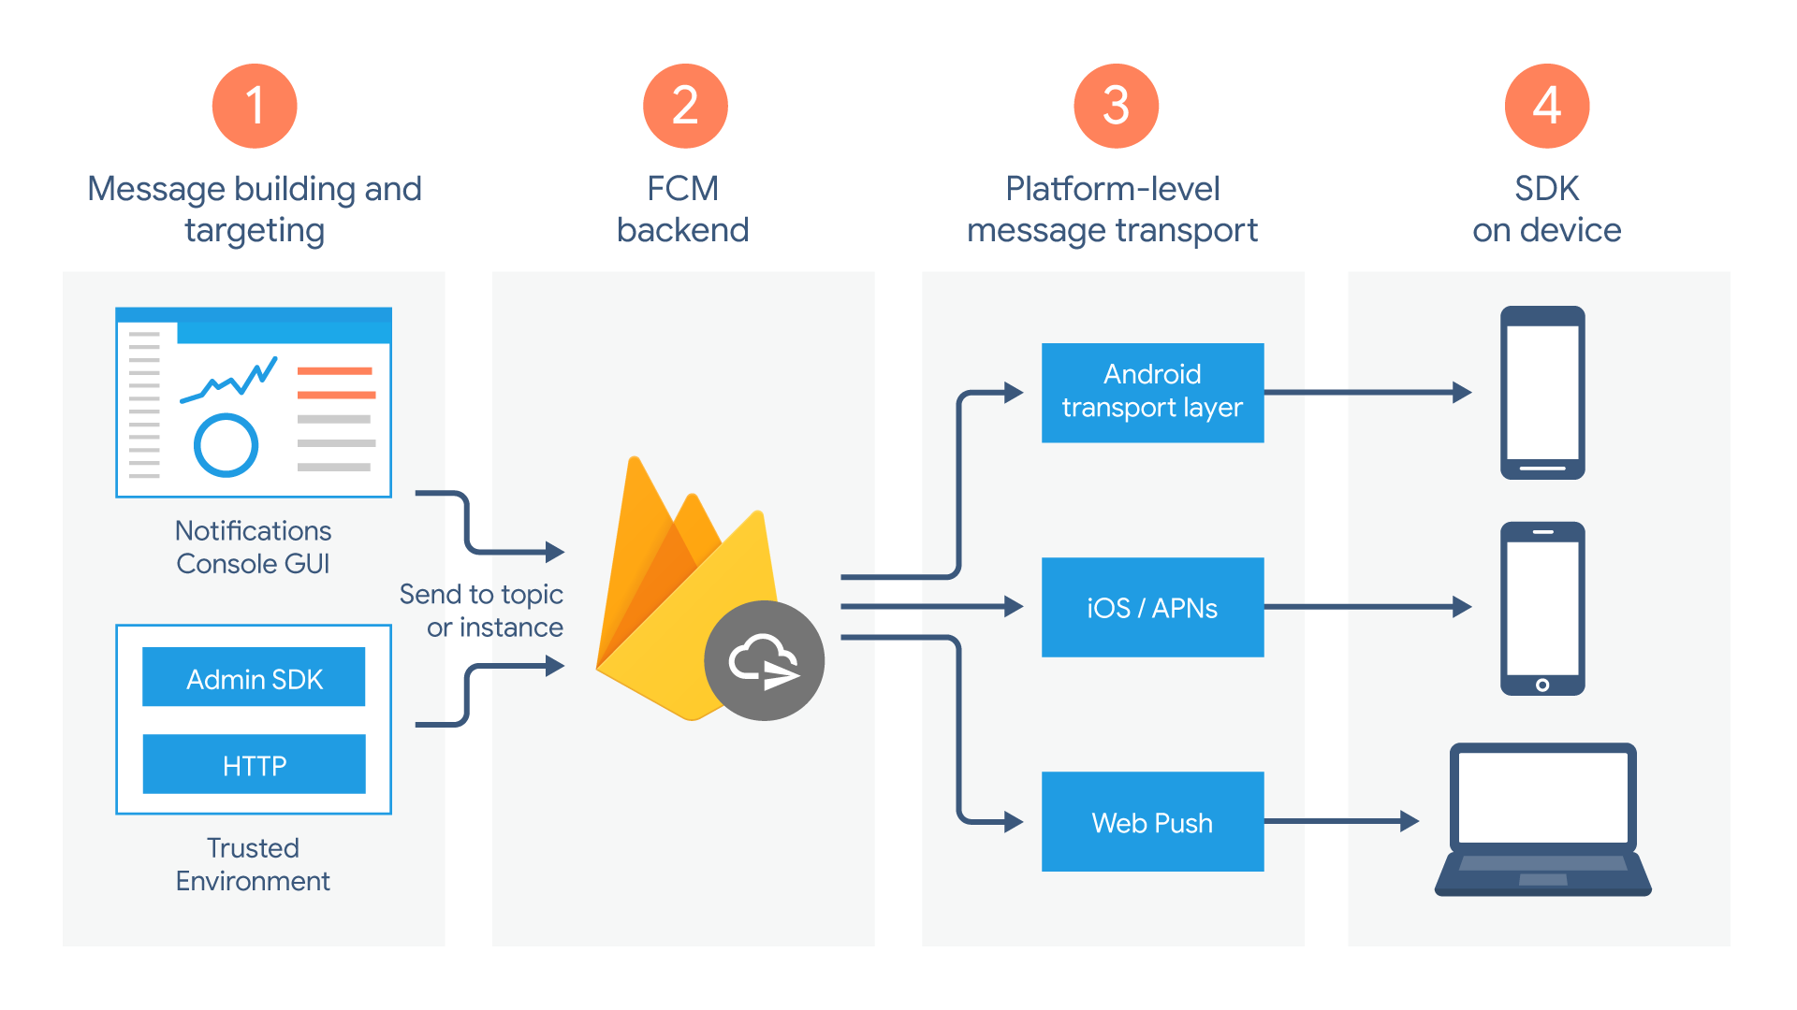

**Flowchart**

The following flowchart illustrate the flow of events in the real-time chat app:

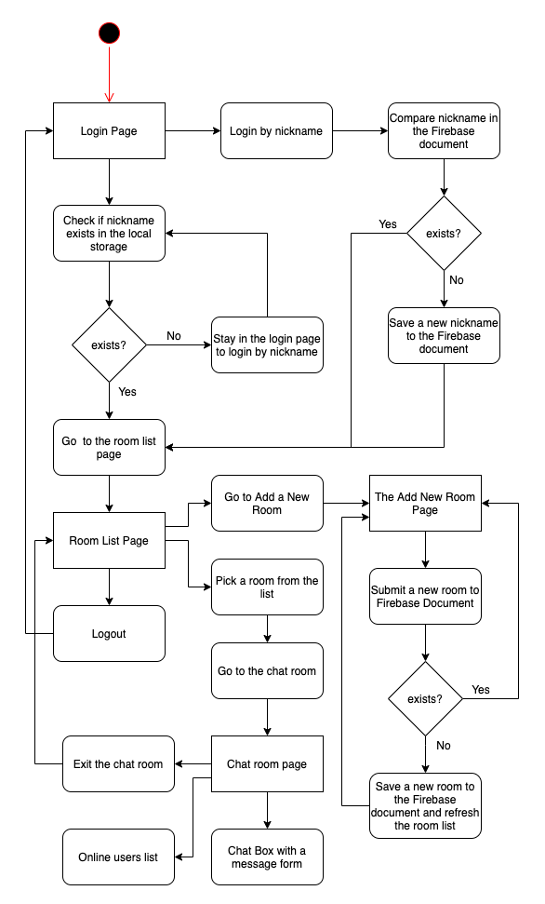

**Features**

* **User Authentication**: User can sign in with their email and password using firebase authentication.
* **Real-time Messaging** : Messaging are instantly synchronized across all connected clients, enabling real-time communication.
* **Simple interface**: The app features are clean and intuitive user interface, making it easy for users to navigate and chat.

**Technologies used**

* React
* Firebase (Authentication, Realtime Database)
* Firebase Cloud Functions

**Getting started**

Prerequisites

Before getting started with the real-time chat app, ensure that you have the following prerequisites:

* Nodejs and NPM installed on your machine.
* Access to the firebase console to create a firebase project.

**Installation**

1. Clone the repository to your local machines

Git clone <http://github.com/oluwatayo123/cyberConnect.git>

1. Navigate to the project directory:

Cd cyberConnect

1. Install dependencies

**Firebase setup**

To set up firebase for the real-time chat app, follow these steps:

1. Create a new project on firebase Console.
2. Add a web app to your firebase project.
3. Copy the firebase configuration object provided and paste it into the ‘src/firebase.js’ file in the project.

**Usage**

To run the real-time chat app locally , follow these steps:

1. Start the development server.

Npm start

1. Open your web browser and navigate to <http://localhost:3000>
2. Sign in with your email and password to start chatting with others in real-time.

**Deployment**

To deploy the real-time chat app to production, you can use services like firebase hosting, Netlify, or vercel (the web app has already been deployed though on vercel).

**Contributing**

Contributions to the real-time chat app are welcome! If you find any issues or have suggestions for improvements, please feel free to open an issue or create a pull request.

**Acknowledgement**

This project was inspired by firebase’s official documentation and various react tutorials available Online.

**Ui Screenshots**

* Signup page

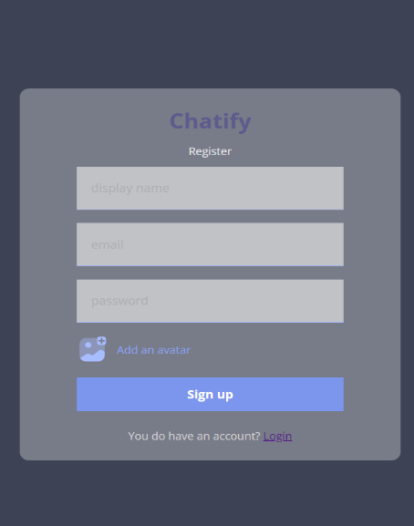

* **Login page**

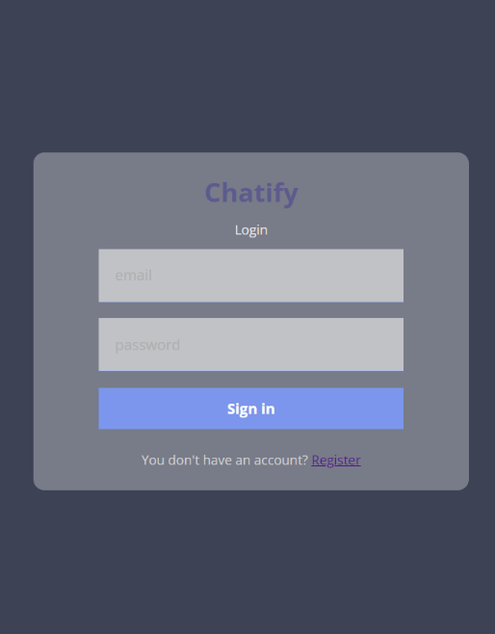

**Chat interface:**

